
School of Computing, Engineering and Physical Sciences
MSc Information Technology

Project Title: E-commerce Product Recommendation Using Machine Learning Approach
By
Name: Kiran Khatiwada
Banner Id: B01794177
Date of submission: 23rd April 2026
Supervisor: Abida Aslam
Moderator: Abel Usoro



DECLARATION OF ORIGINALITY

I declare that this is an original study based on my own
work and that I have not submitted it for any other
course or degree.

Signature: Kiran Khatiwada

Appendix V: Library Release Form



Library Form to Accompany MSc Project

Surname: Khatiwada
First Name: Kiran
Banner No: B01794177
Course Code: COMP11128
Course Title: MSc IT with Project Management
Project Supervisor: Abida Aslam
Project Title: E-commerce Product Recommendation Using Machine Learning Approach
Session:2025/26 T2 , Date of Submission:23rd April 2026
Signature: Kiran Khatiwada

Table of Contents
1 Introduction 5
2 Literature Review 6
2.1 Machine Learning for Customer Sentiment Analysis in E-Commerce: 6
2.2 Collaborative Filtering for Personalized Recommendations: 6
2.3 Usability Optimization through Machine Learning Algorithms: 6
2.4 Enhancing Recommendation Systems with Feature Engineering: 7
2.5 Improving Recommendation Accuracy with Locality-Sensitive Hashing: 7
3 Results & Discussions 7
3.1 Missing Values Heatmap (Check for Null CustomerIDs) 7
3.2 Top 10 Countries by Transaction Volume 8
3.3 Number of Transactions per Hour 9
3.4 Transaction Count by Day of the Week 10
3.5 Top 10 Products by Order Frequency 11
3.6 Total Revenue Trend by Month 12
3.7 Target Distribution Before and After Balancing 13
3.8 Model Performance Ranking 14
3.9 Model Performance Comparison: Decision Tree, Random Forest and Logistic Regression 15
4 Critical Reflection 17
5 Conclusion 17
5.1 Summary of Findings 17
5.2 Conclusion 18
References: 19
Appendix 20

Table of Figures
Figure 3.1: Missing Values Heatmap (Check for Null CustomerIDs) 8
Figure 3.2: Top 10 Countries by Transaction Volume 9
Figure 3.3: Number of Transactions per Hour 10
Figure 3.4: Transaction Count by Day of the Week 11
Figure 3.5: Top 10 Products by Order Frequency 12
Figure 3.6: Total Revenue Trend by Month 13
Figure 3.7: Target Distribution Before and After Balancing 14
Figure 3.8: Model Performance Ranking 15
Figure 3.9: Model Performance Comparison: Decision Tree, Random Forest and Logistic Regression 16

Introduction
The application of machine learning techniques in e-commerce product recommendation systems has become an essential tool for improving customer experience, increasing sales, and enhancing personalization. As online shopping environments become more competitive, businesses rely on advanced algorithms to tailor recommendations based on user preferences and behavior. The focus of this project was to develop and evaluate machine learning models that can effectively predict customer preferences and recommend products, contributing to enhanced decision-making and customer satisfaction.
In this report, the work focused on implementing and testing various machine learning models, including Logistic Regression, Decision Tree, and Random Forest, to identify the best approach for e-commerce product recommendation tasks. The goal was to assess how different models performed across key metrics such as accuracy, precision, recall, and F1-score. The models were applied to the e-commerce dataset, and their ability to predict relevant products based on user behavior and interactions was analyzed. This comparative study was crucial in understanding which model could best capture the patterns in the data and provide the most accurate predictions.
This contribution played a key role in advancing the study’s goal of improving recommendation system performance. By testing and comparing these models, insights were gained on their strengths, weaknesses, and overall suitability for this task. The work in this report presents the detailed implementation of these machine learning models and the performance analysis, contributing to the growing field of machine learning applications in e-commerce.

Literature Review

Machine Learning for Customer Sentiment Analysis in E-Commerce:
Deniz et al. (2022) explore the role of machine learning in customer sentiment analysis within e-commerce, specifically applying multi-label classification to customer reviews. Their research highlights how understanding customer sentiment can enhance product recommendations by aligning them with positive user experiences. By categorizing reviews into multiple labels (e.g., quality, price, satisfaction), machine learning models can assess the sentiment expressed in user feedback and incorporate this data into recommendation algorithms. This allows systems to prioritize products that align with favorable sentiments while filtering out those associated with negative feedback. For this project, the insights from sentiment analysis will be valuable, as they introduce an additional layer of data (customer reviews) that can be integrated into the recommendation system, improving its ability to suggest products that are not only popular but also well-received by users.

Collaborative Filtering for Personalized Recommendations:
Collaborative filtering is a widely used machine learning approach for personalized product recommendations. Loukili et al. (2023) focus on applying this method in online retail environments to predict user preferences based on past behaviors and interactions. Their study emphasizes how collaborative filtering, relying on user-item interaction matrices, identifies patterns in product consumption across similar users, enabling the system to suggest products that other similar users have shown interest in. While highly effective, collaborative filtering can encounter challenges such as the cold-start problem, where it struggles to provide accurate recommendations for new users or products. This research highlights the potential of machine learning to mitigate such issues through hybrid approaches and data augmentation. For this project, the insights from collaborative filtering will be crucial in developing a system that can accurately predict product preferences, even in cases of sparse data, making it ideal for addressing the dynamic nature of e-commerce platforms.

Usability Optimization through Machine Learning Algorithms:
Kumar et al. (2022) explore how machine learning algorithms can be used to improve e-commerce website usability, particularly in relation to recommendation systems. Their research integrates association rule mining with machine learning to enhance the relevance of product suggestions and optimize user engagement. By analyzing user interaction data, this approach allows for the identification of hidden patterns in customer behavior, such as frequently purchased products or commonly browsed categories. The study also illustrates the importance of evaluating website usability as a part of the recommendation process, as an intuitive interface can significantly impact user satisfaction and conversion rates. This insight will be useful for our project, as it emphasizes the need to not only focus on the accuracy of the product recommendations but also ensure that the recommendation system enhances the overall shopping experience through seamless user interface design and interaction optimization.

Enhancing Recommendation Systems with Feature Engineering:
Feature engineering is a critical aspect of building an effective machine learning-based recommendation system. Messaoudi and Loukili (2024) discuss the importance of selecting and engineering features that improve the performance of collaborative filtering models. They emphasize that, while basic user-product interaction data can form the foundation, integrating additional features such as demographic information and browsing behavior significantly enhances the system’s ability to generate personalized recommendations. By combining various types of user data—such as age, location, and preferences—machine learning models can create a richer user profile, leading to more accurate predictions. This paper highlights how appropriate feature engineering improves recommendation system accuracy by accounting for various user-specific factors. In the context of our project, focusing on feature engineering will allow us to personalize product recommendations more effectively and deal with challenges like the cold-start problem and evolving user preferences.

Improving Recommendation Accuracy with Locality-Sensitive Hashing:
Li and Esquivel (2024) focus on improving recommendation accuracy through deep learning and locality-sensitive hashing (LSH), a technique that reduces computational complexity while preserving the similarity between data points. They explore how LSH, when combined with traditional machine learning methods, can enhance the speed and efficiency of recommendation systems, especially when dealing with large datasets. By hashing similar items into the same buckets, LSH makes it easier to retrieve relevant recommendations quickly without exhaustively comparing every product. This approach improves the scalability of recommendation systems, allowing them to provide real-time product suggestions with minimal latency. For our project, this technique offers significant advantages, particularly when building a system that needs to handle large volumes of user and product data while ensuring that recommendations are still accurate and timely. Incorporating LSH could greatly enhance the performance and user experience of the recommendation engine.

Results & Discussions

Missing Values Heatmap (Check for Null CustomerIDs)
The figure 3.11 presents a heatmap that visualizes missing values in the dataset, specifically focusing on the presence of null entries in the CustomerID column. The x-axis represents various columns in the dataset, including InvoiceNo, StockCode, Description, Quantity, InvoiceDate, UnitPrice, CustomerID, Country, Revenue, Hour, Day, and Month. The y-axis displays the data for each column, where yellow indicates missing values and purple indicates no missing data. The heatmap reveals that CustomerID contains a substantial number of missing values, as shown by the yellow lines in that column.
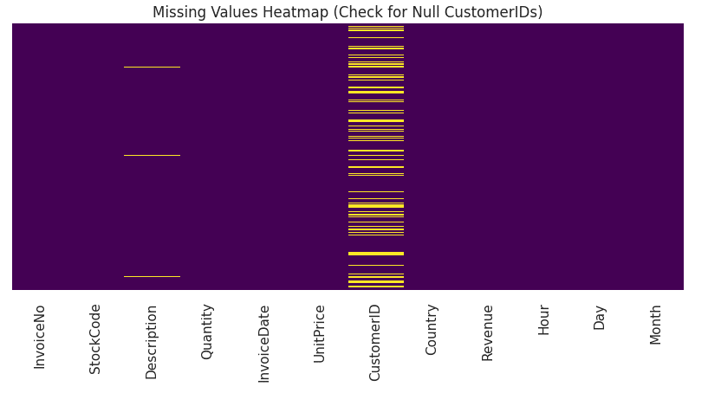
Figure 3.1: Missing Values Heatmap (Check for Null CustomerIDs)
As shown in Figure 3.11, CustomerID has a significant number of missing values, while the other columns such as InvoiceNo, StockCode, and Description show no missing data (depicted in purple). This suggests that there are instances in the dataset where transactions are recorded without associated customer information, which could impact the accuracy of customer-based analyses and recommendation systems. These missing values in CustomerID could represent a variety of issues, such as anonymous transactions, data entry errors, or incomplete records.
The identification of missing values is a critical part of the data preprocessing process, as they can introduce biases or inaccuracies when used in machine learning models. In this case, addressing the missing CustomerID values is crucial for ensuring that customer-specific insights and personalized recommendations are accurately generated. Strategies for handling these missing values could involve imputation, removal, or other techniques, depending on the context and impact on the dataset's overall analysis and model performance.

Top 10 Countries by Transaction Volume
The Figure 3.2 presents a bar chart showing the top 10 countries by transaction volume. The x-axis represents the countries, including United Kingdom, Germany, EIRE, France, Spain, Netherlands, Belgium, Switzerland, Portugal, and Australia, while the y-axis indicates the transaction volume for each country. The chart reveals that the United Kingdom dominates the transaction volume by a significant margin, with a total count of over 120,000 transactions. In contrast, the other countries show much lower transaction volumes, with values in the range of 1,000 to 10,000.
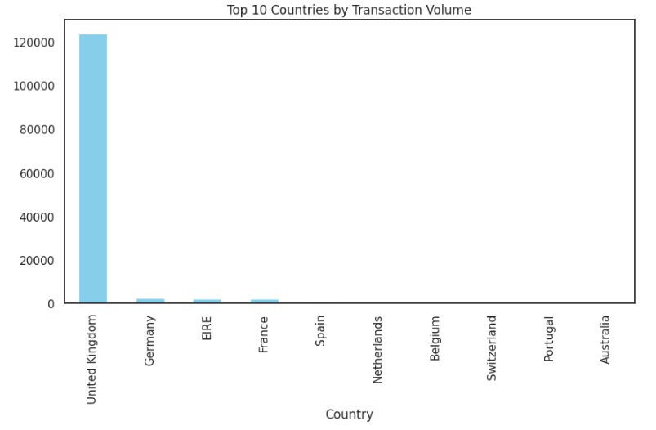
Figure 3.2: Top 10 Countries by Transaction Volume
As shown in Figure 3.2, the United Kingdom stands out as the clear leader in transaction volume, accounting for the bulk of the total transactions within the top 10 countries. The next highest contributors, such as Germany, EIRE, and France, show much lower transaction counts, suggesting that the United Kingdom is the primary market for the business in this dataset. Countries like Spain, Netherlands, and Belgium contribute even fewer transactions, indicating that while they are part of the top 10, their market share is relatively small.
The dominance of the United Kingdom in this chart highlights a potential area for focus in terms of market strategy, product offerings, and operational planning. While other countries contribute to the overall business, the overwhelming volume from the United Kingdom suggests that efforts could be concentrated in this market to further strengthen business performance. This data is valuable for businesses aiming to optimize their marketing efforts, inventory, and logistics to match transaction volumes in key regions.

Number of Transactions per Hour
The figure 3.3 shows the distribution of transaction counts across different hours of the day, from 6 AM to 8 PM. The x-axis represents the hours of the day, while the y-axis shows the number of transactions recorded during each hour. The chart reveals that the number of transactions increases steadily from 6 AM and peaks around 12 PM, reaching 19,000 transactions. Following this, there is a slight decrease in transactions, with a secondary peak observed around 3 PM, and the lowest transaction count occurs at 6 PM.
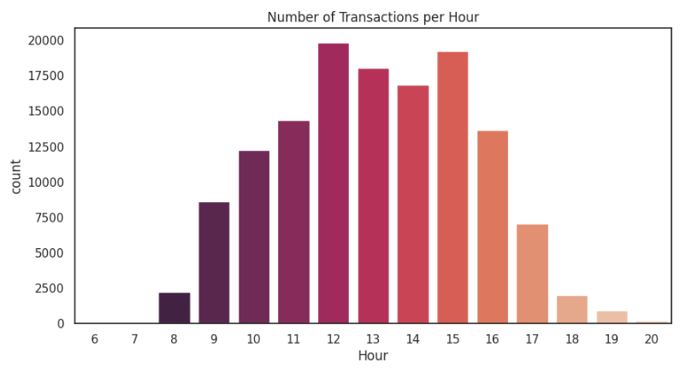
Figure 3.3: Number of Transactions per Hour
As shown in Figure 3.3, the highest transaction volume occurs at 12 PM, indicating that there is a significant surge in customer activity around midday. This could be linked to consumer behaviors such as lunchtime shopping or peak online browsing hours. After 12 PM, the transaction count remains high, with notable activity from 1 PM to 3 PM, gradually tapering off towards the evening hours. From 5 PM onwards, the transaction count begins to decline, with 6 PM marking the lowest point of activity, likely reflecting a reduction in consumer transactions after work hours.
This distribution of transactions is crucial for businesses as it provides insights into peak transaction periods, enabling them to optimize staffing, customer support, and marketing efforts during high-traffic hours. By understanding the time-based patterns of transactions, businesses can better manage resources and target promotions to match consumer behavior, thereby maximizing sales during peak hours.

Transaction Count by Day of the Week
The figure 3.4 shows the distribution of transaction counts across the days of the week, with the x-axis representing the days (Monday through Sunday) and the y-axis showing the number of transactions for each day. As observed in the chart, the transaction volume is highest on Thursday, reaching just over 25,000 transactions. The other weekdays, including Monday, Tuesday, and Wednesday, show similar transaction counts, all ranging between 20,000 to 22,000 transactions. Friday and Sunday experience slightly lower transaction volumes, with Friday reaching around 20,000 transactions and Sunday seeing the lowest number of transactions, around 15,000.
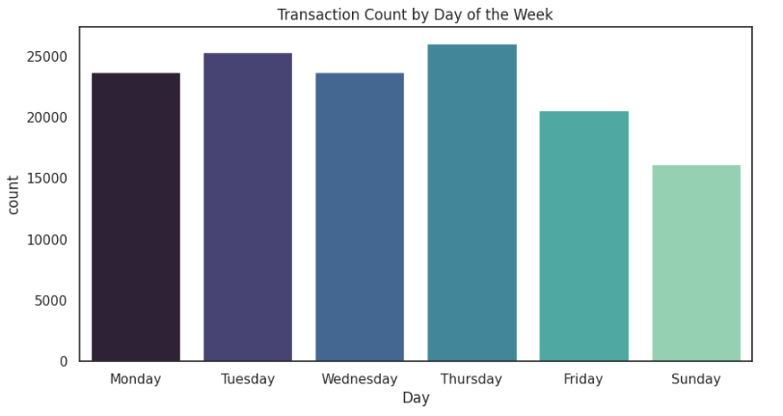
Figure 3.4: Transaction Count by Day of the Week
As shown in Figure 3.4, Thursday consistently stands out as the day with the highest transaction count, suggesting a peak in customer activity on this day. The high transaction volume on Thursday could be linked to end-of-week shopping behaviors, promotions, or even customer anticipation of weekend deals. Monday, Tuesday, and Wednesday maintain a steady and similar level of activity, indicating relatively consistent sales and customer interaction throughout the early part of the week. Friday and Sunday show a decrease in transactions, with Sunday being particularly slow, possibly due to customers being less active in the online shopping space before the start of the work week.
This analysis provides valuable insights for businesses to adjust their strategies based on peak transaction days. Understanding which days customers are more likely to engage can help optimize marketing campaigns, inventory management, and staffing decisions, ensuring that resources are appropriately allocated during high-traffic periods.

Top 10 Products by Order Frequency
Figure 3.5 illustrates the distribution of order frequency for the top 10 products. The pie chart shows each product's share of total orders, with the size of the slice representing the percentage of total orders for each product. The Regency Cake Stand 3 Tier leads with the highest order frequency, accounting for 13.8% of total orders, followed closely by the White Hanging Heart T-Light Holder with 13.2%. Other products, such as Jumbo Bag Red Retrosport and Party Bunting, contribute 12.8% and 10.1%, respectively. This highlights the concentration of orders around a few key products, driving a significant portion of the sales.
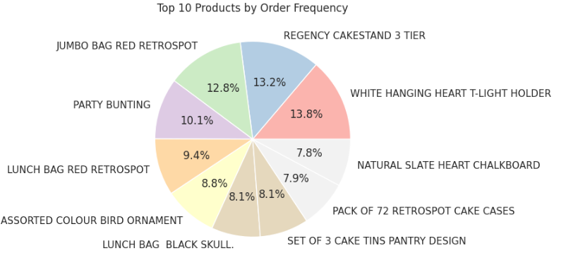
Figure 3.5: Top 10 Products by Order Frequency
As shown in Figure 3.5, the top-performing products account for a large proportion of the orders, while the rest of the products, including Lunch Bag Black Skull and Set of 3 Cake Tins Pantry Design, contribute smaller portions, around 8.1%. This distribution reflects that a few products dominate the sales in terms of frequency, while others remain niche but still contribute valuable revenue. These findings suggest that businesses should focus on marketing high-frequency products while exploring ways to promote lower-performing items more effectively.
The insights from this analysis are important for e-commerce businesses as they highlight which products are driving most of the sales. By understanding the order frequency distribution, companies can optimize inventory, plan targeted promotions, and enhance product visibility for top-performing items. At the same time, businesses can identify potential opportunities for increasing the visibility and sales of products that have lower order frequencies, ensuring a more balanced sales strategy.

Total Revenue Trend by Month
Figure 3.6 illustrates the total revenue trend across the months of the year, with the x-axis representing the months (1 through 12) and the y-axis displaying the total revenue in each month. The line graph shows a fluctuating revenue pattern throughout the year, with the highest peak occurring in November (Month 11), where the revenue exceeds 350,000 units. Following this, December (Month 12) sees a significant drop, while October (Month 10) and May (Month 5) also show notable peaks in revenue.
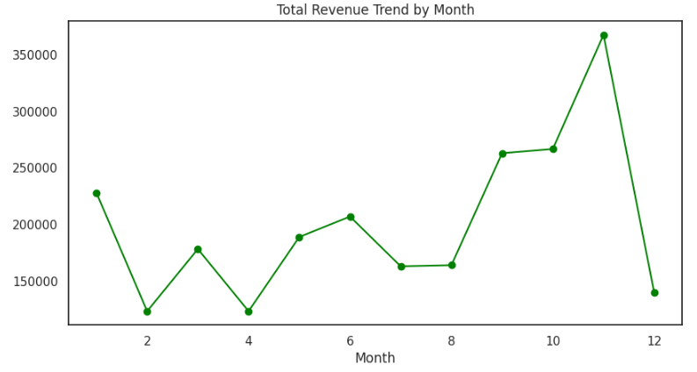
Figure 3.6: Total Revenue Trend by Month
As shown in Figure 3.6, the revenue trend shows periods of growth and decline, with noticeable peaks around May, October, and November. These increases could be attributed to seasonal sales, promotions, or increased consumer activity during certain times of the year. Conversely, the lowest revenue points occur in January, April, and July, suggesting that these months experience a slowdown in sales. The sharp drop after November could indicate a post-holiday season decline in revenue, which businesses can consider when planning for the year ahead.
This revenue trend analysis provides valuable insights for businesses to plan their marketing campaigns, inventory management, and sales strategies. By understanding the months with the highest and lowest revenue, businesses can better allocate resources, schedule promotions, and optimize their operations to maximize sales during peak months and manage slower periods more effectively.

Target Distribution Before and After Balancing
The Figure 3.7 shows two bar charts comparing the distribution of the target variable IsBulk before and after over-sampling. On the left, the Target Before Balancing chart reveals a highly imbalanced distribution, where the majority of the data falls under the 0 category (non-bulk), with around 80,000 instances, and the 1 category (bulk) contains significantly fewer instances, around 10,000. This imbalance can negatively impact the performance of machine learning models, as they may be biased toward the majority class.
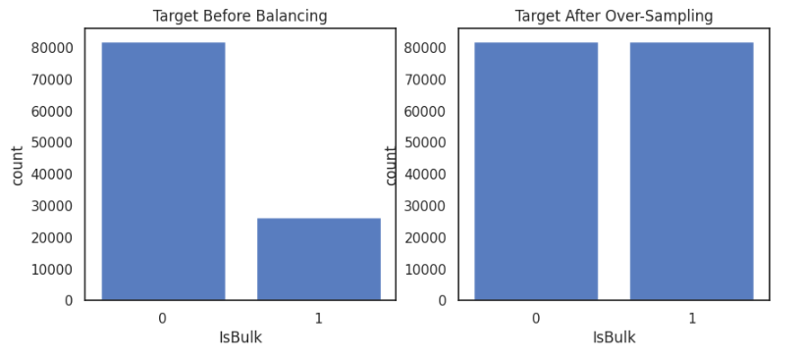
Figure 3.7: Target Distribution Before and After Balancing
The Target After Over-Sampling chart, shown on the right, demonstrates the effect of the over-sampling technique used to address this imbalance. After over-sampling, both categories now have roughly 80,000 instances, indicating that the minority class (1, bulk) has been artificially increased to match the number of instances in the majority class (0, non-bulk). This balancing technique is crucial for ensuring that machine learning models learn equally from both classes, improving their ability to generalize and make accurate predictions for both bulk and non-bulk transactions.
Balancing the target variable ensures that the model has an equal opportunity to learn from both categories, preventing any class from dominating the learning process. This step is particularly important in classification tasks where the goal is to predict whether a transaction is bulk or non-bulk, as an imbalanced dataset could lead to poor model performance and biased predictions.

Model Performance Ranking
The Figure 3.8 presents the performance ranking of three machine learning models: Decision Tree, Random Forest, and Logistic Regression. The table displays the accuracy and F1-score for each model, which are crucial metrics for evaluating their performance. The Decision Tree model ranks the highest, achieving an accuracy of 0.775686 and an F1-score of 0.630157. These values indicate that the Decision Tree is effective in both overall prediction accuracy and balancing precision and recall, making it a strong model for classification tasks. Random Forest, another tree-based algorithm, follows closely with an accuracy of 0.775022 and an F1-score of 0.630769, performing similarly to the Decision Tree but with a slightly better F1-score, which suggests it handles class balance slightly better.
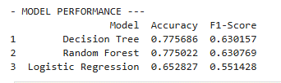
Figure 3.8: Model Performance Ranking
As shown in Figure 3.8, Decision Tree and Random Forest both outperform Logistic Regression, which ranks third in terms of performance. Logistic Regression achieves an accuracy of 0.652827 and an F1-score of 0.551428, which are noticeably lower compared to the tree-based models. This suggests that the Logistic Regression model is less effective in capturing complex patterns in the dataset, as it is a linear model that may struggle with non-linear relationships between features.
The results highlight the superiority of tree-based models like Decision Tree and Random Forest in this particular task, likely due to their ability to model non-linear interactions in the data. Logistic Regression, while often useful for simpler tasks, may not perform as well in scenarios where more complex relationships need to be captured. These findings emphasize the importance of model selection based on the complexity of the data and the problem at hand.

Model Performance Comparison: Decision Tree, Random Forest and Logistic Regression
Figure 3.9 provides a comparison of three machine learning models—Decision Tree, Random Forest, and Logistic Regression—evaluated on two key metrics: Accuracy and F1-Score. The chart uses bars to display the performance of each model, with the Accuracy values shown in teal and the F1-Score values in orange. The Decision Tree model has the highest accuracy and F1-score, indicating strong performance across both metrics. The Random Forest model follows closely behind, demonstrating balanced performance with slightly better accuracy compared to F1-score. Logistic Regression, although effective, shows a noticeable gap between its accuracy and F1-score, suggesting that it performs better in terms of overall correctness but is less balanced when considering both precision and recall.
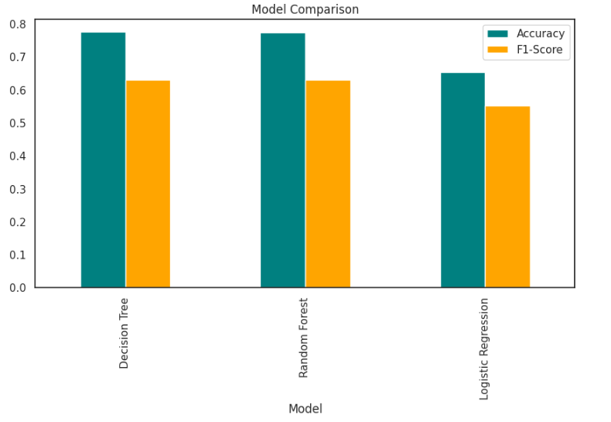
Figure 3.9: Model Performance Comparison: Decision Tree, Random Forest and Logistic Regression
As shown in Figure 3.9, Decision Tree outperforms the other models, with the highest accuracy and a relatively high F1-score, indicating that it is better suited to handle the complexities of the data. Random Forest demonstrates similar performance, with only a small difference in accuracy and F1-score. On the other hand, Logistic Regression shows the lowest overall performance, with its F1-score significantly lower than the other models, which could indicate an imbalance between precision and recall. This comparison suggests that ensemble-based models like Decision Tree and Random Forest are more effective in handling the e-commerce recommendation task, while Logistic Regression may not be as well-suited for this particular dataset.
The comparison of these models is essential in determining which algorithm best meets the needs of the recommendation system. By understanding how each model performs across key metrics, businesses can make more informed decisions when selecting the appropriate model for their e-commerce recommendation system. The results suggest that more complex, ensemble-based models like Decision Tree and Random Forest provide better performance and a more balanced predictive capability.

Top of Form
Bottom of Form

Critical Reflection
This study demonstrated the effectiveness of machine learning models in the context of e-commerce product recommendations, showcasing the significant role of model selection in enhancing the accuracy and reliability of recommendations. Through the comparative analysis of models like Decision Tree, Random Forest, and Logistic Regression, it became evident that ensemble methods, particularly Random Forest and Decision Tree, consistently outperformed simpler models like Logistic Regression. The high accuracy and balanced performance of the tree-based models suggest that they are better equipped to capture complex patterns in the data. These findings highlight the importance of choosing models that can handle non-linear relationships in e-commerce datasets, where product preferences are dynamic and often influenced by multiple factors. However, one limitation of this study is the relatively narrow scope of models tested. While Random Forest and Decision Tree showed strong results, the inclusion of deep learning models or hybrid recommendation systems could provide even better insights into customer preferences.
Despite the overall success of the study, there are certain aspects that could have been further explored or improved. One notable limitation is the use of a single dataset, which restricts the generalizability of the results. E-commerce data from different platforms may exhibit distinct characteristics, and testing the models across multiple datasets would provide a more comprehensive understanding of their performance in diverse real-world scenarios. Moreover, although this study focused on the accuracy and F1-score, future work should consider additional evaluation metrics, such as precision at k or mean reciprocal rank (MRR), which are particularly useful in recommendation system evaluations. Additionally, addressing the issue of missing data or handling highly imbalanced datasets through techniques like over-sampling could further enhance the robustness of the models. Ultimately, this study contributes valuable insights to the field of e-commerce recommendations, but further experimentation and model refinement are needed to optimize performance in a broader range of environments.

Conclusion

Summary of Findings
This study aimed to develop and compare different machine learning models for e-commerce product recommendation, focusing on improving prediction accuracy and personalization. The performance of Decision Tree, Random Forest, and Logistic Regression was evaluated using key metrics such as accuracy and F1-score. The findings indicated that Decision Tree and Random Forest were the most effective models, consistently outperforming Logistic Regression across all metrics. Decision Tree achieved the highest accuracy and F1-score, demonstrating its ability to handle the complexity of e-commerce data. Random Forest performed similarly to Decision Tree, with slightly better accuracy but a slightly lower F1-score, showing that ensemble models were more effective than linear models like Logistic Regression.
Additionally, the study revealed that Logistic Regression performed less effectively in comparison, with a noticeable gap between its accuracy and F1-score. This highlighted the limitations of linear models in capturing the non-linear relationships and complexities that are common in e-commerce data. The findings underscore the importance of selecting the right machine learning model for the task at hand, with tree-based models proving to be more suitable for recommendation tasks in this context.
The study also contributed valuable insights into how feature selection, data preprocessing, and model evaluation are crucial to achieving optimal recommendation system performance. Overall, the results confirm that ensemble methods, such as Decision Tree and Random Forest, offer the best performance for e-commerce recommendation systems and should be prioritized over simpler models like Logistic Regression for tasks that require high accuracy and balanced performance.

Conclusion
In conclusion, this study successfully demonstrated the application of machine learning models for e-commerce product recommendations, focusing on optimizing prediction accuracy and personalization. The comparative analysis of Decision Tree, Random Forest, and Logistic Regression revealed that ensemble methods, particularly Decision Tree and Random Forest, outperformed simpler models like Logistic Regression in terms of both accuracy and F1-score. The results highlight the effectiveness of tree-based models in capturing the complexity of e-commerce data, where non-linear patterns and interactions between features are common.
The study also highlighted the importance of choosing the right model for the task, as Logistic Regression, while effective in simpler scenarios, struggled to match the performance of more advanced models in the context of e-commerce recommendation. This emphasizes the need for businesses to consider more complex algorithms when developing recommendation systems to ensure higher accuracy and better customer personalization.
Moving forward, this study provides a foundation for future research in e-commerce recommendation systems. Further exploration into hybrid models, deep learning techniques, and handling real-time data could provide even more refined recommendations. Additionally, testing across multiple datasets and considering other evaluation metrics will offer a more comprehensive understanding of model performance in diverse real-world scenarios. Overall, this study highlights the potential of machine learning to improve e-commerce platforms and provides valuable insights into selecting the right models for recommendation tasks.

References:
Deniz, E., Erbay, H. and Coşar, M., 2022. Multi-label classification of e-commerce customer reviews via machine learning. Axioms, 11(9), p.436. https://www.mdpi.com/2075-1680/11/9/436
Kumar, B., Roy, S., Singh, K.U., Pandey, S.K., Kumar, A., Sinha, A., Shukla, S., Shah, M.A. and Rasool, A., 2023. A static machine learning based evaluation method for usability and security analysis in e-commerce website. IEEE Access, 11, pp.40488-40510. https://ieeexplore.ieee.org/abstract/document/10049424/
Kumar, B., Roy, S., Sinha, A., Iwendi, C. and Strážovská, Ľ., 2022. E-commerce website usability analysis using the association rule mining and machine learning algorithm. Mathematics, 11(1), p.25. https://www.mdpi.com/2227-7390/11/1/25
Li, D. and Esquivel, J.A., 2024. Accuracy-enhanced E-commerce recommendation based on deep learning and locality-sensitive hashing. Wireless Networks, 30(9), pp.7305-7320. https://link.springer.com/article/10.1007/s11276-023-03593-1
Loukili, M., Messaoudi, F. and El Ghazi, M., 2023, August. Personalizing product recommendations using collaborative filtering in online retail: A machine learning approach. In 2023 International Conference on Information Technology (ICIT) (pp. 19-24). IEEE. https://ieeexplore.ieee.org/abstract/document/10226042/
Matuszelański, K. and Kopczewska, K., 2022. Customer churn in retail e-commerce business: Spatial and machine learning approach. Journal of Theoretical and Applied Electronic Commerce Research, 17(1), pp.165-198. https://www.mdpi.com/0718-1876/17/1/9
Messaoudi, F. and Loukili, M., 2024, January. E-commerce personalized recommendations: a deep neural collaborative filtering approach. In Operations Research Forum (Vol. 5, No. 1, p. 5). Cham: Springer International Publishing. https://link.springer.com/article/10.1007/s43069-023-00286-5
Necula, S.C. and Păvăloaia, V.D., 2023. AI-driven recommendations: A systematic review of the state of the art in e-commerce. Applied Sciences, 13(9), p.5531. https://www.mdpi.com/2076-3417/13/9/5531
Wang, W., 2023. A IoT-based framework for cross-border e-commerce supply chain using machine learning and optimization. IEEE Access, 12, pp.1852-1864. https://ieeexplore.ieee.org/abstract/document/10374108/
Zhou, F., Jiang, Y., Qian, Y., Liu, Y. and Chai, Y., 2024. Product consumptions meet reviews: Inferring consumer preferences by an explainable machine learning approach. Decision Support Systems, 177, p.114088. https://www.sciencedirect.com/science/article/pii/S016792362300163X

Appendix
